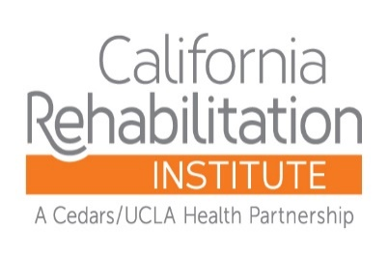

Financial Assistance Policy – Appendix B

Approved by: | Date Last Approved: | Date of Issue: | Version:  2019-1

Printed copies are for reference only. Please refer to the electronic copy for the latest version.

Financial Assistance Policy Appendix B

Providers Not Covered Under the Financial Assistance Policy

The Financial Assistance Policy (FAP) applies to California Rehabilitation Institute. Services provided by the practitioner groups listed below are not covered under this FAP.

This listing is updated quarterly. If you do not see a provider listed here and want to verify whether that person is covered under this FAP, please contact admissions at our facility or call Customer Service at (888) 868-1103.

Practice Name:

